**HOME**





Responsive?

Scrolling section in servizi: is it possible to have an hover effect? Like the **video**.

 this is “Mappa”



Please change this logo in every single footer page because the cross in the middle is not visible, but don’t make the corner rounded.

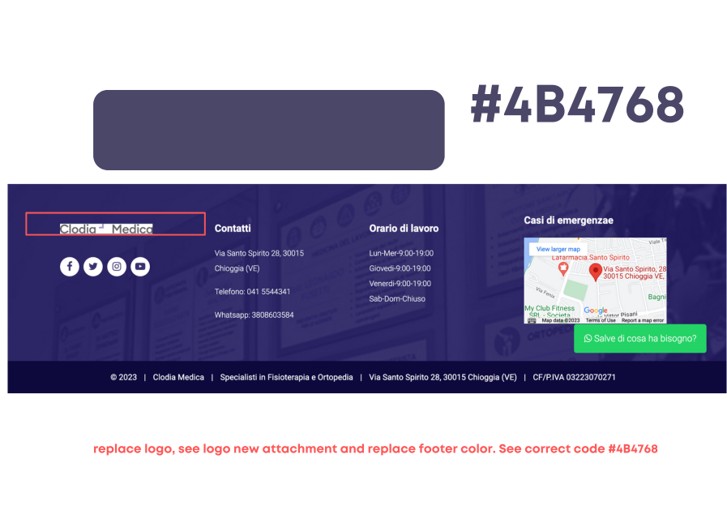

replace logo, see logo new attachment and replace footer color. See corrected code #4B4768- put in light transparency





This is not a page to display on the menu because it’s an inner page. The link is: when you click on “come prepararsi” in the “punto prelievi” page, i twill be loaded the “come prepararsi” page. This is the only way a person can see the “come prepararsi” page. Let me know if you get it.

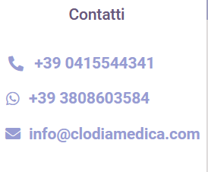 if possible please remove light blue when you visit the website with smartphone. I know it’s clickable but we don’t like it.

SAME FOR HAMBURGER MENU -phone view-.



Please same size and style (bold).



is it possible to have these 2 looking like the one on the synlab section? White border, hover effect: lilac (color), growing (effect).

Watch below.

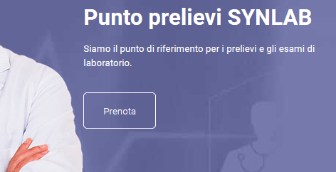https://api.whatsapp.com/send?phone=393808603584

all the buttons on the site must change color when hovered over, see example. and you see these that are not. all those that are on the whole site must change color and same effect. EVERYONE ON THE SITE

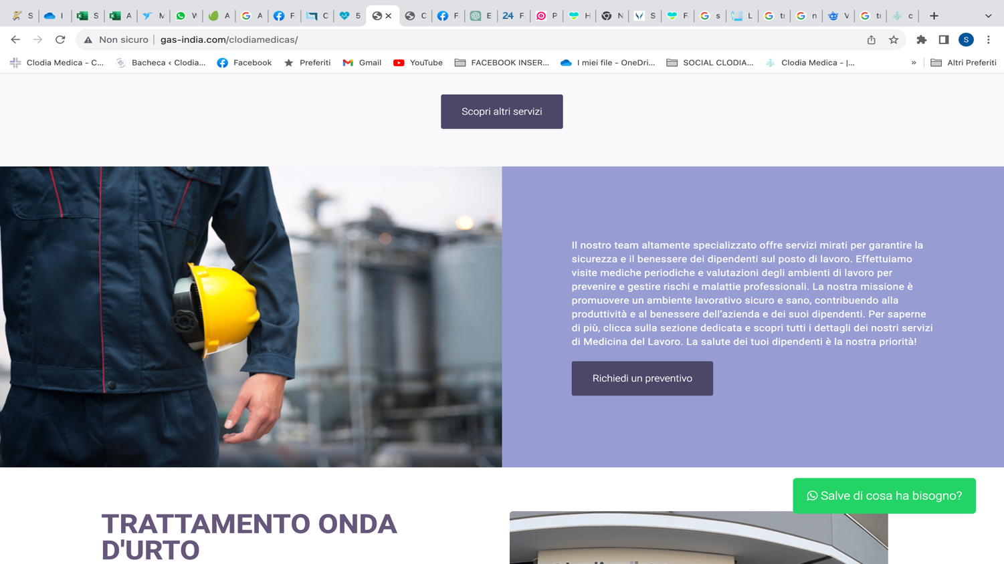

TUTELIAMO IL DATORE DI LAVORO E I LAVORATORI

new image of the occupational medicine service. and new text.

Title: TUTELIAMO IL DATORE DI LAVORO E I LAVORATORI

Text :

Clodia Medica: il partner dedicato alla sicurezza e al successo. Il nostro servizio di medicina del lavoro è un ponte tra la tutela dei lavoratori e il supporto ai datori di lavoro. Non si tratta solo di garantire il benessere individuale, ma di creare un ambiente aziendale solido e protetto. Con una gamma completa di servizi dedicati, lavoriamo affinché ogni dipendente sia al sicuro e ogni impres sia in regola

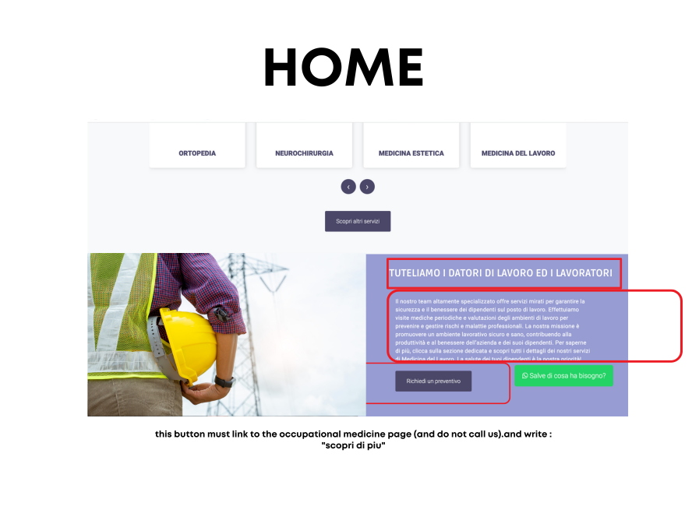

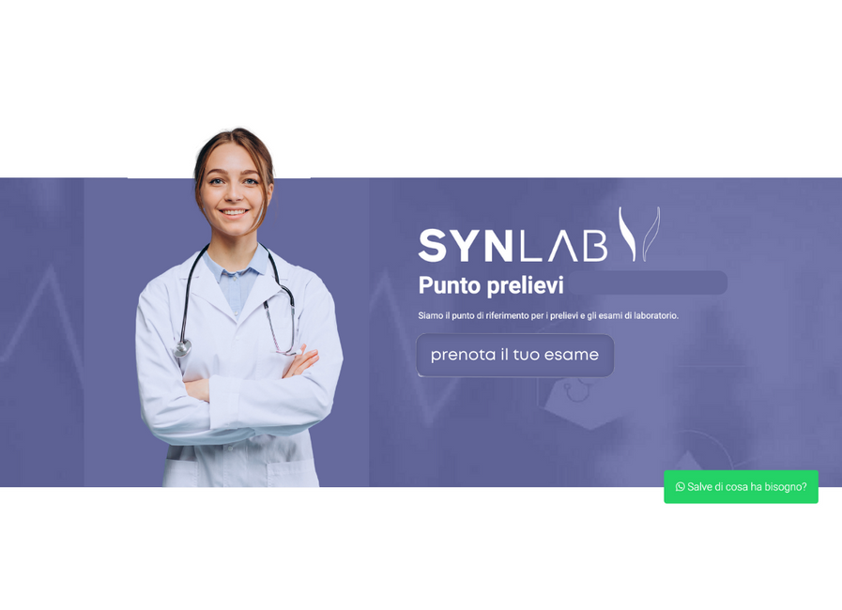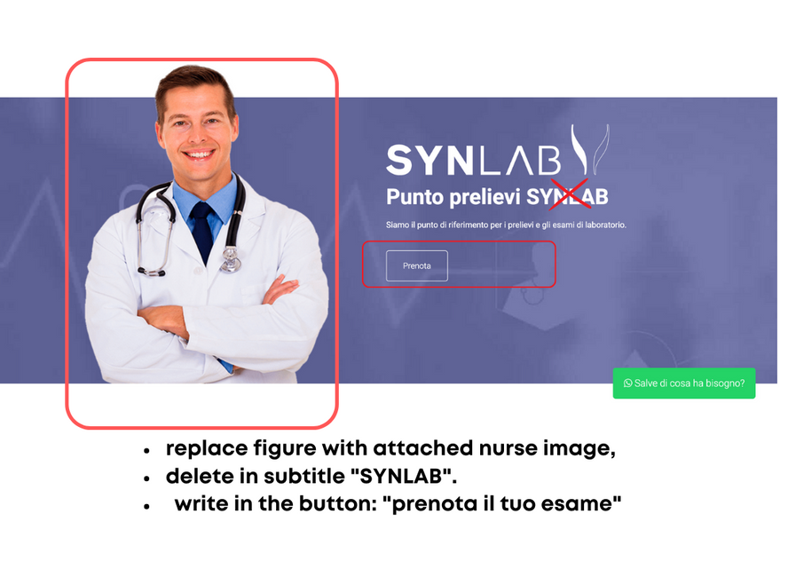

qewgtryj



Text in the button: “scopri altri servizi”

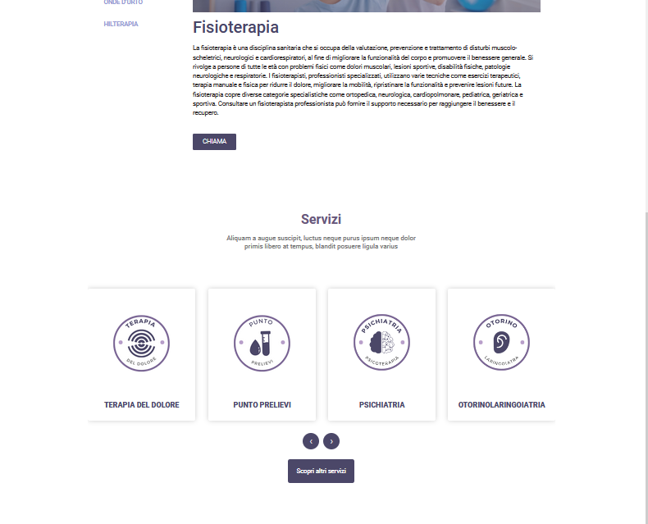

Is it possible to duplicate this slideshow? So we can only change the images when we have them ready because we wanna have “fisioterapia” icons. We want here a slideshow of icons but not with service but with fisioterapia services in the specific because this is fisioterapia which is not part of services. Let me know if you don’t get it. Sara already told you.

For the same slideshow, in each page: we’d like to have some effects we really like. I’m sending a **video** so you understand what we’d like to have.

For the “servizi” slideshow: this is the sentence we wanna have below! At the moment there’s a text like “lorem ipsum.” Check every single one please.

Have a look below:

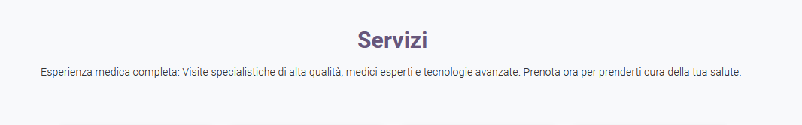

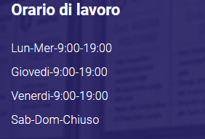 please write them correctly in every single page. See homepage hour times section “orari di apertura” (Lun-Ven 9-12 / 14-18:30 Sab-Dom chiuso).

Also: please change color as asked several times. Try this please: # 776391



Hese 2 doctors needs to be removed. The first one “massimo mancini” only temporarly (he’ll be back in the next 2 months so we don’t want it deleted forever – hide it), the second one left forever so please delete him. Same, have a look at the scrolling section in the homepage because i twill be done the same there.

Also the service below please:

 hide it.

CONTATTI

Tel.: 0415544341

WA: 3808603585

E-: info@clodiamedica.com

Sabato e domenica chiuso

Orario punto prelievi:

Martedì e giovedì 07:30/09:00

Orari di segreteria:

Lun-Ven 09:00/12:00 – 14:00/18:30

H E A D E R

ORARIO RITIRO REFERTI

Per il ritiro dei referti, gli orari sono:

da lunedì a venerdì 10:00/12:00 – 14:00/18:30

- - - - - - - - - - - - - - - - - - - - - - - - - - - - - - - - - - - - - - - - - - - - - - - - - - - - - - - - - - - - - - - - - - - - - - - - - - - - - - - -

- - - - - - - - - - - - - - - - - - - - - - - - - - - - - - - - - - - - - - -

Red dashed lines are useful to understand alignment, don’t have to be added as you guys did. What I meant was: we wanted the middle section text to be aligned like you see in the scheme I created here above.

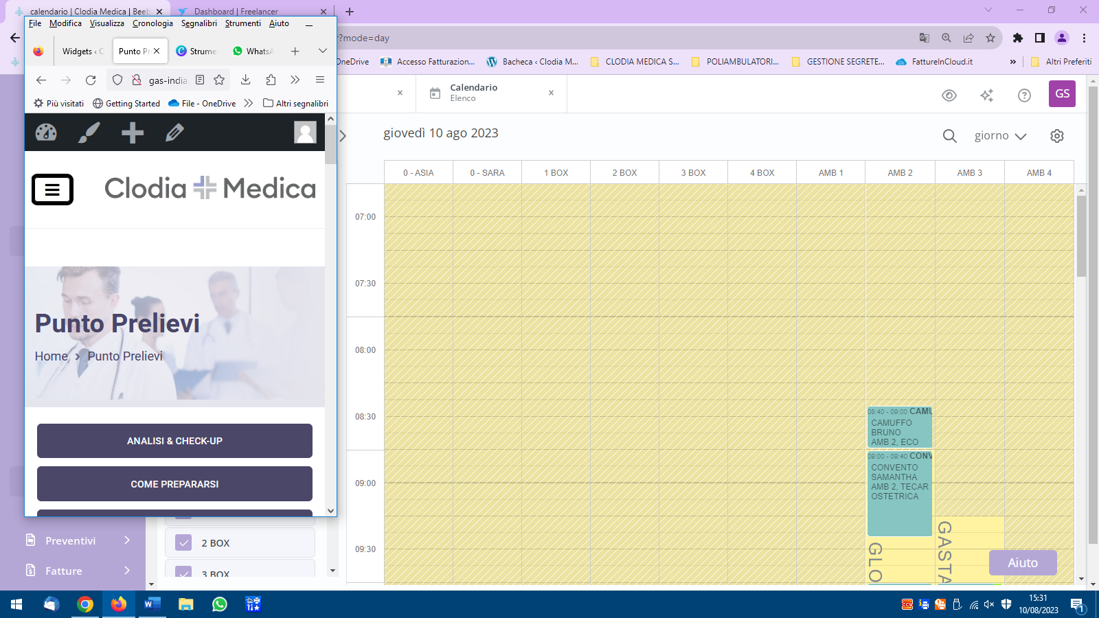We don’t like such a thick border (the black one – you can see it in the red box I placed to highlight the issue). Thanks.



Can you please check if this button leads to keypad? People need to call us when they click on this button because basically it’s for booking an appointment for a nurse who come visit you at home as you can’t leave home.

In “servizi” page, scrolling servizi section is missing,why? I don’t remember we told you to remove it. Can you please add it?

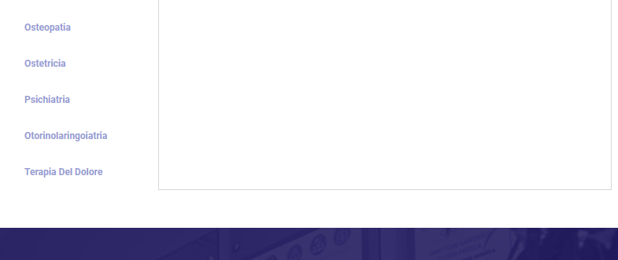



This is in “medicina del lavoro” page. I changed the photo because I like it more something like this one, but width is not enough. Can you please help me out or solve in some ways?

Then:

* Left button: replace text🡪 Scarica la brochure gratuita🡪Chiedi un preventivo (clicking the button will lead to the form at the beginning of the page);
* Right button: Chiamaci will lead to the keypad so people can call us.

Blog section at the bottom of the page: we are sending texts and image. Can you add a “Chiamaci” button at the end of the article so people can call us? Button will lead to the phone keypad as well, like all the other “Chiama” buttons.



Is it possible to open google maps or something like that when you click on the address on top of the page?

As a final request: please have a look at the phone visualization because we want everything correctly aligned, paired, and set correctly on the page. Same for the global visualization of the website.

SARA IS GONNA SEND:

* TEXT AND IMAGE to replace “terapia onda d’urto” in the hompage.
* 1 more doctor to add.
* Text and image for “medicina del lavoro” section in homepage
* New image to replace the next one, and add signature of sara and indication:
* Sara Boscolo, Head of the Clinic:

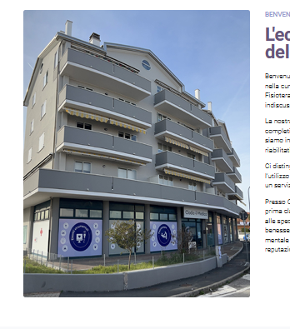

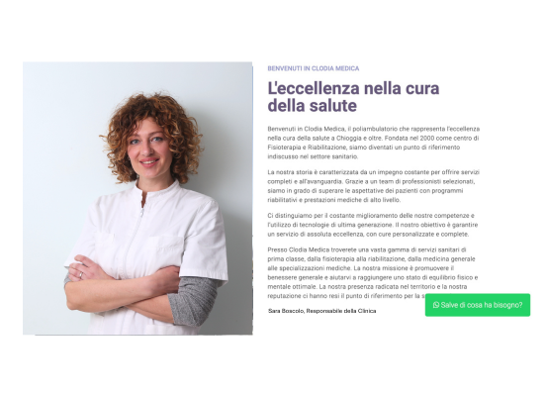

Sara Boscolo, Responsabile della Clinica



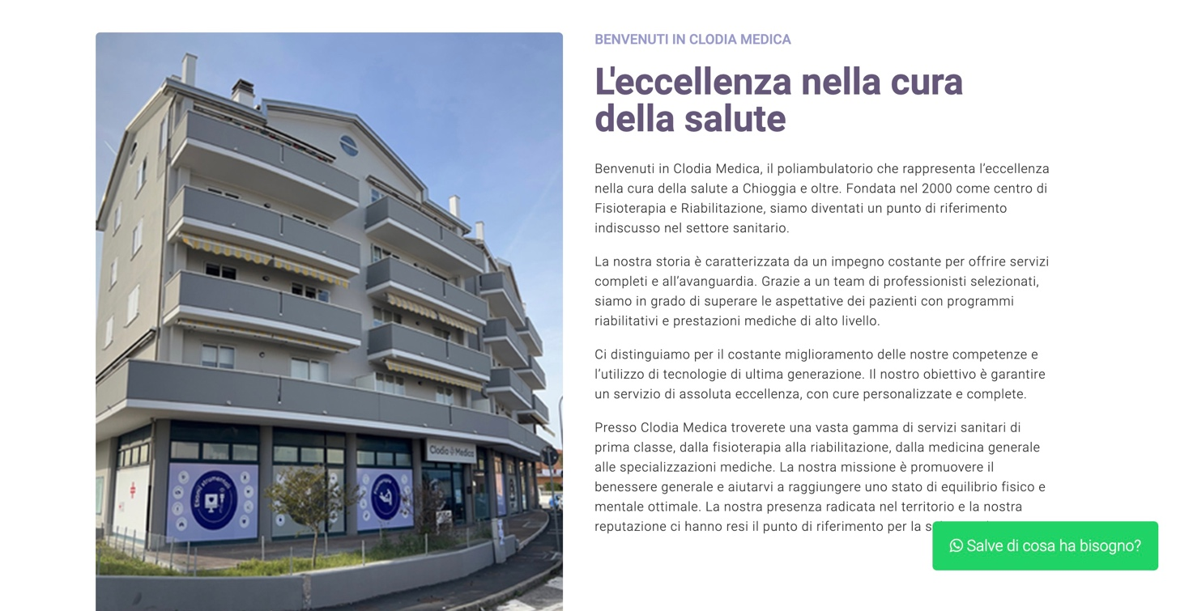

->New image HEADER

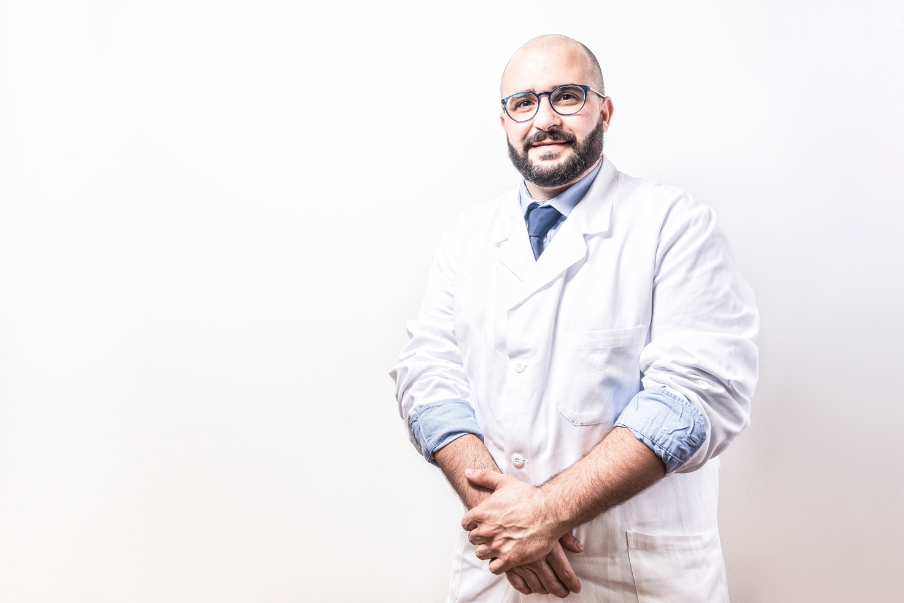

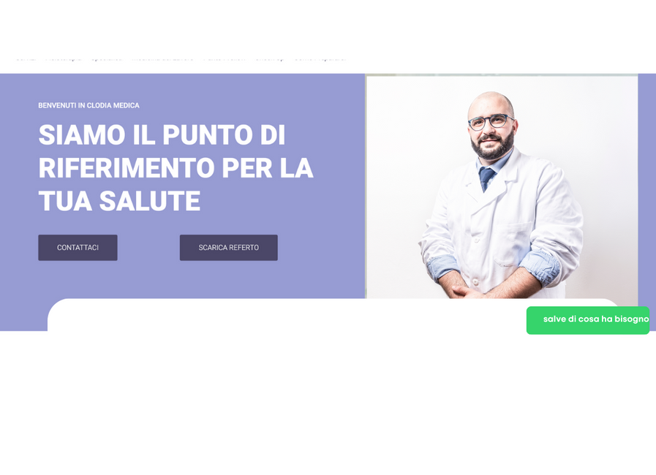

new title: ECCELENZA DELLA FISIOTERAPIA E RIABILITAZIONE

NEW TEXT

NEW BOTTON : scopri di piu

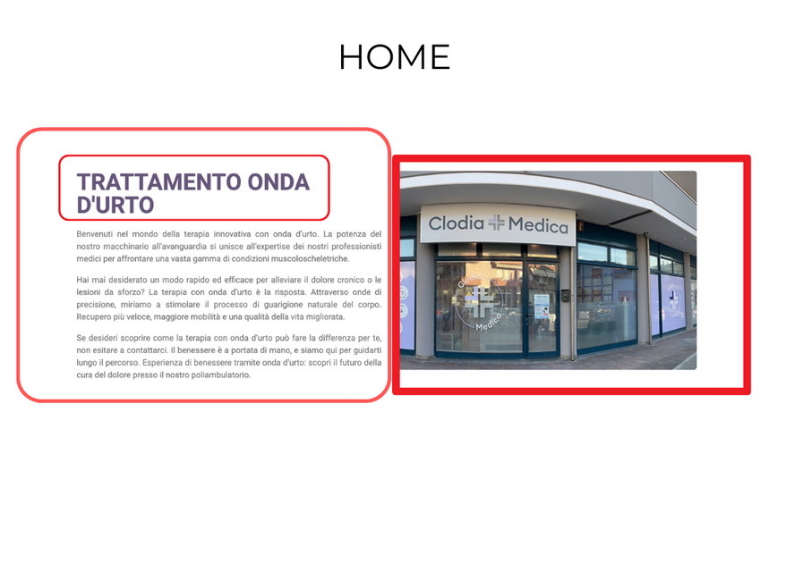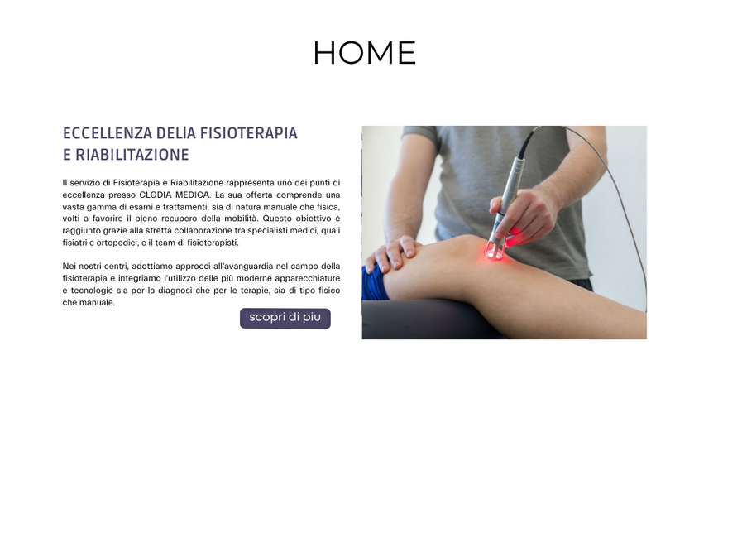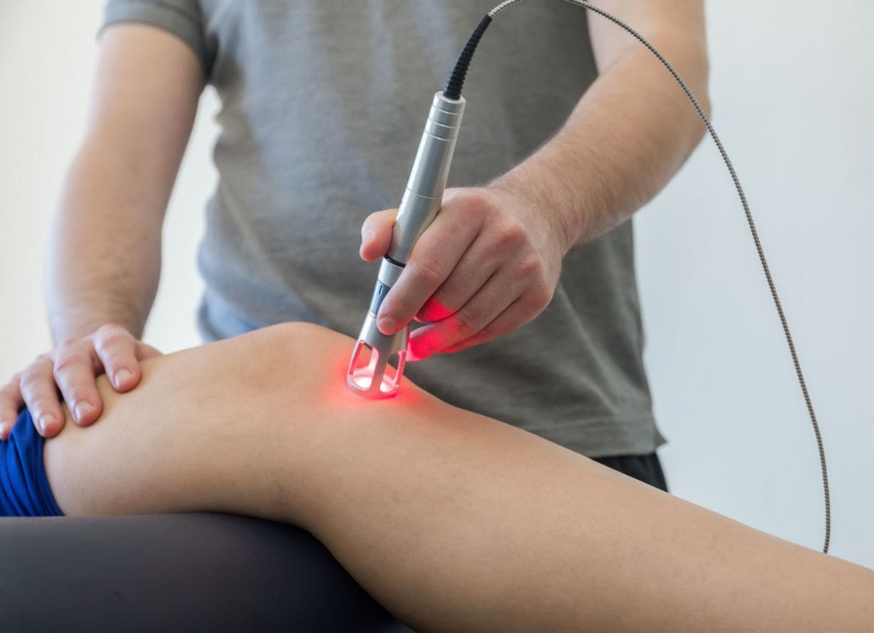

Il **servizio di Fisioterapia e Riabilitazione** rappresenta uno dei **punti di eccellenza** presso CLODIA MEDICA. La sua offerta comprende una vasta gamma di **esami e trattamenti**, sia di natura **manuale che fisica**, volti a favorire il **pieno recupero della mobilità**. Questo obiettivo è raggiunto grazie alla stretta collaborazione tra **specialisti medici**, quali **fisiatri e ortopedici**, e il team di **fisioterapisti**.

Nei nostri centri, adottiamo approcci all'avanguardia nel campo della **fisioterapia** e integriamo l'utilizzo delle più moderne **apparecchiature e tecnologie** sia per la **diagnosi** che per le **terapie**, sia di tipo **fisico che manuale**.